TI 22 – 14 Technology Example - Kibosh Pipe repair clamp

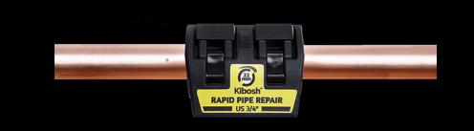

A burst pipe can put an end to a project pretty quickly and pipes leak and burst for many reasons; frost damage in winter, accidental perforation by trades people, DIY accidents, old pipe and fittings etc. Whatever the cause of a leaking or burst pipe, water damage starts immediately, and the longer it takes to stop the leak, the more costly the damage. Kibosh is ideal for plumbers who are in the front line in pipe leak situations, as well as other professional trades, maintenance and DIY enthusiasts needing a reliable and effective quick fix, fast.
The Kibosh Rapid Emergency Pipe Repair Clamp is very simple and quick to use. It can stop leaks immediately, limiting and avoiding water damage and disruption. This saves precious water, gets the situation under control and once a Kibosh pipe repair clamp is fitted, the metal or plastic pipe can continue to function normally again under pressure, hot or cold!

Link To vendors website:

Burst pipe - Kibosh Pipe Repair the world’s fastest burst pipe repair

